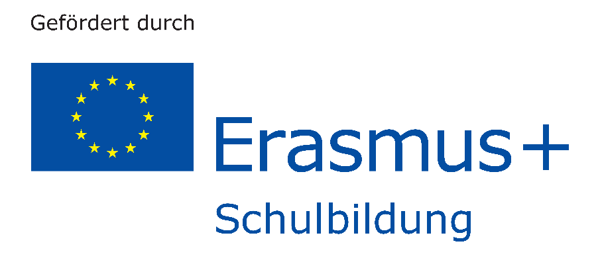

Erasmus + Logo Contest
The purpurse of the contest is to design a logo for our Erasmus+ project „Water – a combining element“. The logo may be used in all media – including online, print, on merchandise and other visual collateral. Following are the official contest rules:
- Goal: To design a logo for our Erasmus+ project „Water a combining element“ which will be used in every document, product an website.
- Requirements: the logo must reflect the nature of the project; therefore it must contain:
  - The project´s theme: water
  - The project´s partners: Greece, Italy, Finland, Germany and Spain.
  - It should contain part of the title (the „motto“): „combining element“
- Participants: every student of every partner school can participate. Each participant can submit only one design.
- Proposal: All submitted work must be the original work of the entrant and must not include, be based on, or derived from any pre-existing or third-party designs, trademarks, or copyrighted images.
- Submission: it can be submitted either in a material or a digital format. The name of the student must be written on a separate paper, since the jury will not know the student’s name. Each school will clarify how the submission will take place.
- Jury: the jury will be consist of the following:
  - Three teachers of each partner school
  - The principal of each partner school.
- Winner: the winner will receive 50 Euros prize (to be spent in school materials) and his/her name will appear on the project´s website as creator of the logo.
- The logo will be property of the Erasmus+ project and it reserves the right to modify the winning logo to better fit the needs of the Initiative.

